EM Algorithm (Expectation-maximization):

What is the EM Algorithm?
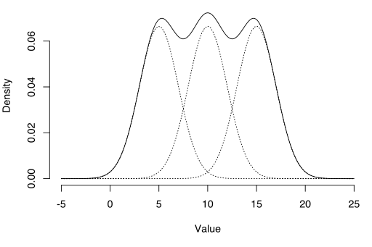
The EM algorithm can be used to estimate latent variables, like ones that come from mixture distributions (you know they came from a mixture, but not which specific distribution).
The Expectation-Maximization (EM) algorithm is a way to find maximum-likelihood estimates for model parameters when your data is incomplete, has missing data points, or has unobserved (hidden) latent variables. It is an iterative way to approximate the maximum likelihood function. While maximum likelihood estimation can find the “best fit” model for a set of data, it doesn’t work particularly well for incomplete data sets. The more complex EM algorithm can find model parameters even if you have missing data. It works by choosing random values for the missing data points, and using those guesses to estimate a second set of data. The new values are used to create a better guess for the first set, and the process continues until the algorithm converges on a fixed point.

MLE vs. EM
Although Maximum Likelihood Estimation (MLE) and EM can both find “best-fit” parameters, how they find the models are very different. MLE accumulates all of the data first and then uses that data to construct the most likely model. EM takes a guess at the parameters first — accounting for the missing data — then tweaks the model to fit the guesses and the observed data. The basic steps for the algorithm are:
- An initial guess is made for the model’s parameters and a probability distribution is created. This is sometimes called the “E-Step” for the “Expected” distribution.
- Newly observed data is fed into the model.
- The probability distribution from the E-step is tweaked to include the new data. This is sometimes called the “M-step.”
- Steps 2 through 4 are repeated until stability (i.e. a distribution that doesn’t change from the E-step to the M-step) is reached.

The EM Algorithm always improves a parameter’s estimation through this multi-step process. However, it sometimes needs a few random starts to find the best model because the algorithm can hone in on a local maxima that isn’t that close to the (optimal) global maxima. In other words, it can perform better if you force it to restart and take that “initial guess” from Step 1 over again. From all of the possible parameters, you can then choose the one with the greatest maximum likelihood.

In reality, the steps involve some pretty heavy calculus (integration) and conditional probabilities, which is beyond the scope of this article. If you need a more technical (i.e. calculus-based) breakdown of the process, I highly recommend you read Gupta and Chen’s 2010 paper.

Applications
The EM algorithm has many applications, including:

Dis-entangling superimposed signals,
Estimating Gaussian mixture models (GMMs),
Estimating hidden Markov models (HMMs),
Estimating parameters for compound Dirichlet distributions,
Finding optimal mixtures of fixed models.

Limitations
The EM algorithm can very very slow, even on the fastest computer. It works best when you only have a small percentage of missing data and the dimensionality of the data isn’t too big. The higher the dimensionality, the slower the E-step; for data with larger dimensionaloty, you may find the E-step runs extremely slow as the procedure approaches a local maximum.

Expectation Maximization with Coin Flips
Expectation Maximization is an iterative method for finding maximum likelihood or maximum a posteriori (MAP) estimates of parameters in statistical models, where the model depends on unobserved latent variables. The best introductory example I've come across, which considers a series of coin flips, is from the paper, "What is the expectation maximization algorithm?", and is also covered in one of University of Michigan's Machine Learning course's lectures and discussion section notes.
While the original paper and course coverage of this example are good, I found that a few key details were glossed over; in this notebook I aim to lay everything out in its entirety, and hope understanding this example in detail will provide intuition for how EM works, laying the foundation to study its theory and more complex examples further.

A coin experiment
Suppose your friend has posed a challenge: estimate the bias of two coins in her possession. They might be fair coins, be more heavily weighted towards heads; you don't know. Here's the clue she's provided: a piece of paper with 5 records of an experiment where she's:
- Chosen one of the two coins at random.
- Flipped that same coint 10 times.
How can you provide a reasonable estimate of each coin bias? Let's refer to these coins as coin A and coin B and their bias as θAθA and θBθB.

We see which coin is flipped
Let's first imagine that this piece of paper shows which coin was chosen for each trial:
coin | flips | # coin A heads | # coin B heads
B | HTTTHHTHTH | 0 | 5
A | HHHHTHHHHH | 9 | 0
A | HTHHHHHTHH | 8 | 0
B | HTHTTTHHTT | 0 | 4
A | THHHTHHHTH | 7 | 0
In this case it's easy, and boils down to estimating each independently. Let's start with coin A: across three trials of 10 flips, there are 24 heads. So a reasonable estimate of the coin bias would be 24/30 or 0.8.
To estimate the bias of coin B, we have 9 heads across 2 sets of 10 flips for an estimated bias of 9/20 = 0.45.
So when we know everything, in the complete data case, our problem is pretty easy.

We don't see which coin is flipped
Now let's make the problem harder: what if we are shown the same trials as above, but do not know which coin was chosen for each set of 10 flips? We only know that each coin has an equal chance of being chosen each time.
In this scenario, the coin is not observed, and could be considered a hidden or latent variable. EM comes in handy for all sorts of so called "latent variable" models, including Gaussian Mixture Models and Hidden Markov Models. This is merely a contrived example to provide as simple a latent variable model as possible.
coin | flips | # coin A heads | # coin B heads
? | HTTTHHTHTH | ? | ?
? | HHHHTHHHHH | ? | ?
? | HTHHHHHTHH | ? | ?
? | HTHTTTHHTT | ? | ?
? | THHHTHHHTH | ? | ?
In this case, we can't simply count the number of heads that showed up for each coin, because we don't know the identity of the coin.

Guessing a solution to get started
Right now we're stuck, because we'd like to count up the number of heads for each coin, but we don't know which coin is being flipped in each trial. It turns out that we can make progress by starting with a guess for the coin biases, which will allow us to estimate which coin was chosen in each trial and come up with an estimate for the expected number of heads and tails for each coin across the trials (E-step). We then use these counts to recompute a better guess for each coin bias (M-step). By repeating these two steps, we continue to get a better estimate of the two coin biases and converge at a solution that turns out to be a local maximum to the problem.

The E-Step
Even assuming we know the biases of each coin, how exactly do we estimate the number of heads and tails for each coin across the trials? One heuristic might be, for each trial, to see which coin bias better matches the flips and attribute all flips to that coin. So, for example, if we see HHHHHHHHTT and our current assumed biases for A and B are 0.4 and 0.7 respectively, it seems more likely that it was coin B, so for that trial, we just assume it is coin B and tally up "8 heads and 2 tails for coin B".
This approach seems ok, but what about cases that aren't so obvious? Like what if the trial is HHHHHTTTTT and our current assumed biases for A and B are 0.4 and 0.6? Assigning all of the flips to either coin for our estimate doesn't seem very accurate.

Estimating liklihood each coin was chosen
Let's not force ourselves to assume one coin or the other, but instead estimate the probability that each coin is the true coin given the flips we see in the trial, and use that to proportionally assign heads and tails counts to each coin. Let's make this concrete with one of the examples we just mentioned:
- our current biases for coin A and B are 0.4 and 0.7
- we observe the following flips: HHHHHHHHTT
what is the probability that these flips came from coin A and coin B? Let's call this series of flips event EE, the event we chose A be ZAZA and B ZBZB.
First, let's assume we know it is coin A, with probability of heads 0.4 (and tails 0.6). What is the probability of seeing 'HHHHHTTTTT'? We want to know the probability that a specific sequence of successes (heads) occured in a fixed set of trials (flips), which is exactly what the probability distribution of a binomial random variable tells us:
P(E|ZA)=P(HHHHHHHHTT|A chosen)=10!8!2!0.480.62P(E|ZA)=P(HHHHHHHHTT|A chosen)=10!8!2!0.480.62
Similarly, if we assume it was coint B, the probability of seeing these flips would be:
P(E|ZB)=P(HHHHHHHHTT|B chosen)=10!8!2!0.780.32P(E|ZB)=P(HHHHHHHHTT|B chosen)=10!8!2!0.780.32
Thanks to Baye's theorem and the law of total probability, we can partition all of the events in ZZ (which coin we choose) over ZAZA and ZBZB as we have to choose one or the other.
P(ZA|E)=P(E|ZA)P(ZA)P(E|ZA)P(ZA)+P(E|ZB)P(ZB)P(ZA|E)=P(E|ZA)P(ZA)P(E|ZA)P(ZA)+P(E|ZB)P(ZB)
We know P(ZA)=P(ZB)=0.5P(ZA)=P(ZB)=0.5 as that's how we've constructed the problem (equal chances of choosing A and B), so the expression simplifies to:
P(ZA|E)=P(E|ZA)P(E|ZA)+P(E|ZB))=10!8!2!0.480.6210!8!2!0.480.62+10!8!2!0.780.32=0.480.620.480.62+0.780.32=0.0435P(ZA|E)=P(E|ZA)P(E|ZA)+P(E|ZB))=10!8!2!0.480.6210!8!2!0.480.62+10!8!2!0.780.32=0.480.620.480.62+0.780.32=0.0435
and for coin B:
P(ZB|E)=0.780.320.480.62+0.780.32=0.0956P(ZB|E)=0.780.320.480.62+0.780.32=0.0956
So this passes our intuition: if we see 8 heads out of 10, it is much more likely that the coin with bias 0.7 was the coin chosen than the coin with bias 0.3.
Applying the same arithmetic to the other scenario with trial HHHHHTTTTT and biases for A and B are 0.4 and 0.6, we find that each coin is equally likely (0.5) to have been chosen, also matching our intuition.
More generally, for a given trial EE with number of heads hh and number of tails tt = 10 - hh:
P(ZA|E)=θhA(1−θA)tθhA(1−θA)t+θhB(1−θB)tP(ZA|E)=θAh(1−θA)tθAh(1−θA)t+θBh(1−θB)t
and
P(ZB|E)=θhB(1−θB)tθhA(1−θA)t+θhB(1−θB)tP(ZB|E)=θBh(1−θB)tθAh(1−θA)t+θBh(1−θB)t

Assigning expected number of flips to each coin
Now that we have an estimate for the relative likelihood each coin was chosen, we can estimate the number of heads and tails for each coin by multiplying these probabilities by the number of heads and tails in a trail.
Here's one "E-step" filled out assuming our current parameters are θ0aθa0 = 0.6 and θ0bθb0 = 0.5.
flips | probability it was coin A | probability it was coin B | # heads attributed to A | # heads attributed to B
HTTTHHTHTH | 0.45 | 0.55 | 2.2 | 2.8
HHHHTHHHHH | 0.8 | 0.2 | 7.2 | 1.8
HTHHHHHTHH | 0.73 | 0.27 | 5.9 | 2.1
HTHTTTHHTT | 0.35 | 0.65 | 1.4 | 2.6
THHHTHHHTH | 0.65 | 0.35 | 4.5 | 2.5

The M-Step
Once we have an estimate for the number of heads and tails for each coin, how do we improve our estimate for the coin biases? This part is easy: for each coin we divide the expected number of heads by the number of total flips, just like we did for the simplified scenario where we know which coin was chosen each time.
θ1a=2.2+7.2+5.9+1.4+4.510∗(.45+.8+.73+.35+.65)=0.71θa1=2.2+7.2+5.9+1.4+4.510∗(.45+.8+.73+.35+.65)=0.71
θ1b=2.8+1.8+2.1+2.6+2.510∗(.55+.2+.27+.65+.35)=0.58θb1=2.8+1.8+2.1+2.6+2.510∗(.55+.2+.27+.65+.35)=0.58
Another way to put it: we are M-is-for-m-m-maximizing the likelihood of the flip counts we estimated in the e-step by assuming the coin biases match up proportionally.
With updated estimates for θaθa and θbθb, we can repeat the E-step again.
To review, we take a problem of estimating coin biases that would be easy if we had the complete data, that is, if we knew which coin was chosen, and made it tractable by iteratively:
- Assuming we have the coin biases, computing the expected number of heads and tails for each coin for the trials we see (the E-step)
- Given these counts of heads and tails, providing an improved guess at the coin biases by simply dividing the number of heads by total flips for each coin.
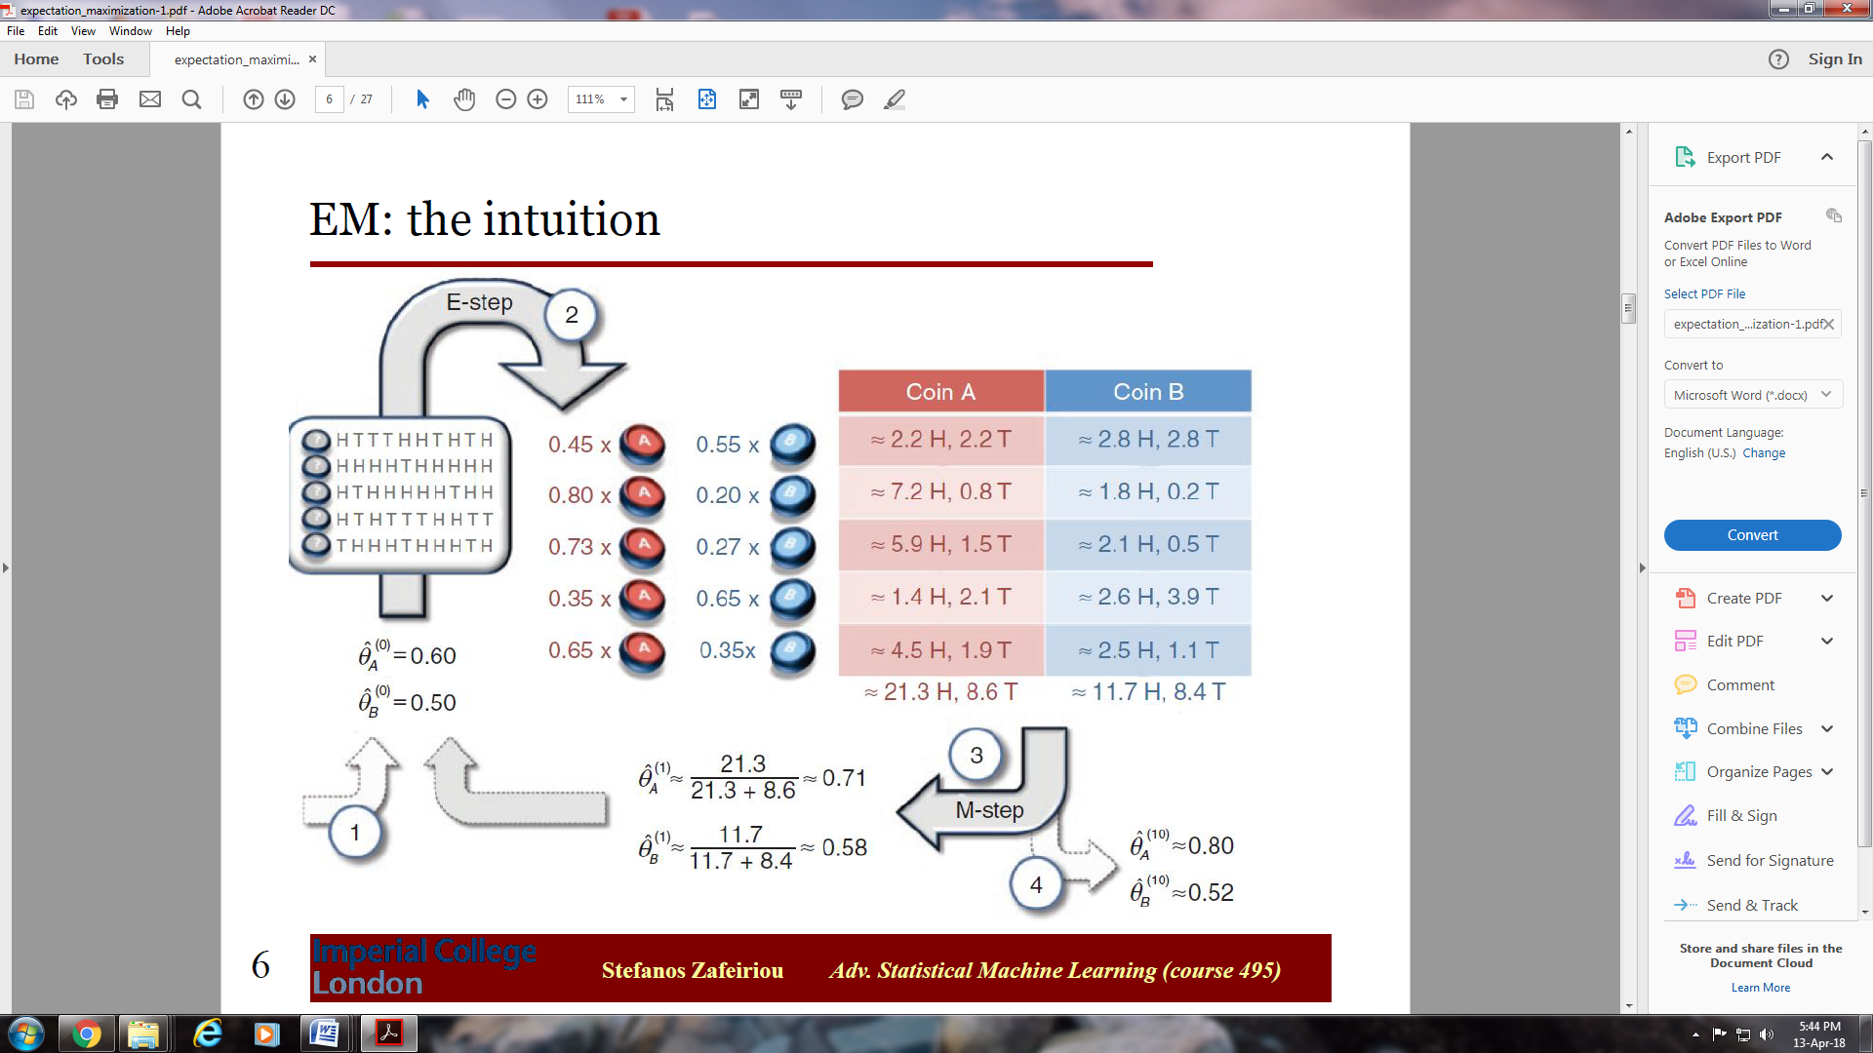
EM in general
More generally, the EM algorithm helps us estimate the parameters of a probability distribution where:
- We are given samples from the distribution where some of the variables are missing
- If we had access to these missing values, estimating the parameters would be easy
by iteratively:
- Guessing the parameters of the distribution and using this to fill in or characterize the values of the missing data (the E-step)
- With these estimates for the missing data in hand, easily updating the values of our model

